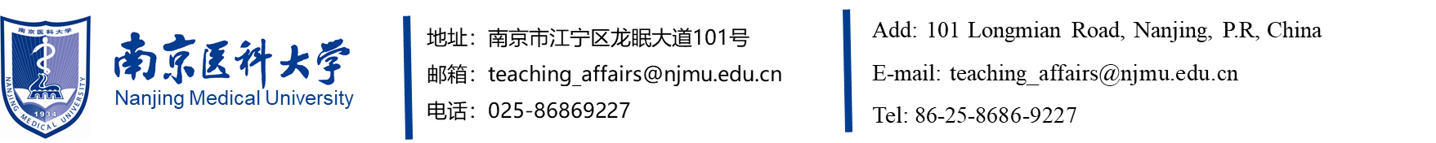

CERTIFICATE OF GRADUATION
This is to certify that , male/female, born on , attended a year course in the specialty of
at this university from to and has successfully fulfilled all the requirements of the prescribed Master/Ph. D. course and passed the thesis defense. Graduation is hereby granted.

President, Nanjing Medical University
Chairman, Academic Degree Evaluation Committee of
Nanjing Medical University
Certificate No.:
Issued on:

此处复制粘贴毕业证书缩印件

The same copy and the original

