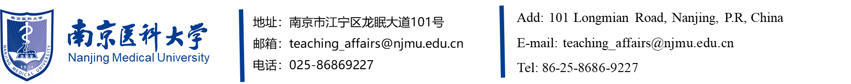
CERTIFICATE FOR THE DEGREE OF DOCTOR/MASTER
This is to certify that , male/female, born on , having passed all examinations and the oral defense of dissertation and fulfilled the requirements of the University in the specialty of , is hereby awarded the Degree of Doctor/Master of in accordance with the Regulations of the People’s Republic of China on Academic Degrees.

President, Nanjing Medical University
Chairman, Academic Degree Evaluation Committee of
Nanjing Medical University
Certificate No.:
Issued on:

此处复制粘贴学位证书缩印件

The same copy and the original

